Update – Hepatitis C Prevention and Treatment in Prisons
by Niki Miller, AHP Senior Research Associate
Hepatitis C (HCV) affects about 1% of the U.S. population as a whole, but more than 17% of the overall prison population. In some states, a much larger proportion of inmates are infected. Testing for HCV is available in many prisons, but it is not always offered routinely. Many states only test inmates at-risk for HCV infection, such as those reporting a history of injection drug use. This approach offers some short-term economic advantages, but it is also likely to miss the opportunity to identify a significant proportion of infected inmates, an opportunity that many experts say offers significant public health benefits.
However, prisons may now have a disincentive for implementing universal testing protocols. Correctional systems have a constitutional mandate to provide health care to inmates. Specifically, they cannot display deliberate indifference to apparent health care needs. The prohibitive costs of new, highly effective direct-acting antiviral drugs (DAA’s) approved for treating HCV can make prison systems reluctant to identify every infected individual. Prison health care budgets are limited, and the HCV treatment price tag can overwhelm them. For this reason, since 2002, there have been an increasing number of law suits over access HCV treatment in prisons (see list of links to related articles below). Massachusetts, Minnesota, Pennsylvania, and Oregon are among the growing list of state correctional departments that have been sued by inmates over access to treatment. Suits have also been filed in response to attempts to restrict Medicaid coverage of HCV treatment for all infected individuals living in the community, in several states.
Here are examples of how various prison systems have dealt with this critical health care issue.
About 17,000 California prison inmates have tested positive for hepatitis C, although experts speculate the actual number infected is much higher. In 2014, California began treating prisoners with DAA’s at a cost of $70,000 to $80,000 per treatment and a total projected expenditure of over $57 million to treat more than 900 inmates. New York State has treated more than 600 inmates, sustaining a 350% spending increase on HCV medications. In contrast, Florida is reported to have only treated five inmates last year; Texas reportedly treated 43, although there are plans to ramp up treatment. The chart below compares spending in four prison systems.
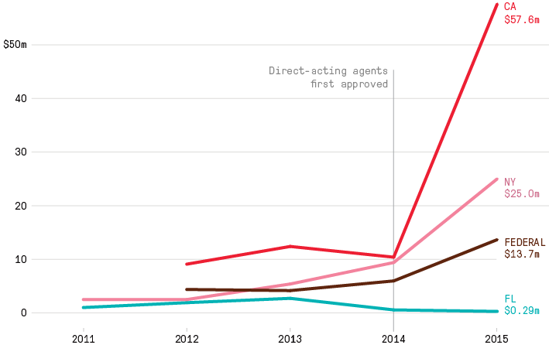
Two issues that contribute to the correctional cost burden: prison systems generally do not have the negotiating power of insurers when it comes to dealing with pharmaceutical companies and are usually forced to pay full price for the new drugs. Second, new research on the cost effectiveness of routine testing and treatment of HCV in prisons shows that long-term savings and other benefits are largely realized by communities, not correctional systems.
Spending on hepatitis C by prison agencies (Marshall Project, 2016)
Source: The Federal Bureau of Prisons, New York State Department of Corrections
& Community Supervision, California Correctional Health Care Services, Florida DOC

A recent study analyzed the costs of implementing universal HCV testing in prisons and estimated it would require a 12% increase in correctional health care spending (He et al, 2015). Although treatment outcomes for inmates appear to be quite positive, the high costs of the drugs are a significant barrier, especially when many infected inmates are asymptomatic. The newest DAA medication approved for treating HCV is less expensive (estimated cost of treatment is $54,000). The hope is that more competitive options will become available, but the patents on the new class of drugs will not begin to expire until after 2025.
Amid all the controversy there are some resources that may help justice professionals to deal with the dilemma at hand. The Federal Bureau of Prisons (BOP) updated its clinical guidelines in 2016 to include universal voluntary screening of all inmates and a level system that prioritizes candidates for treatment according to indicators of medical necessity. Oregon’s policy came out of a mediated settlement in response to an early inmate suit, which preceded the approval of DAA medications, but its comprehensive DOC policy on HCV has been updated regularly. Washington State has worked with a community based Hepatitis Education Project to implement an inmate education program. One thing is for certain, an ounce of prevention is sure to be worth a pound of cure.
Resources and Examples of Correctional Policies and Programs
-BOP 2016 Clinical Guidelines for the Evaluation and Management of Chronic HCV Infection: https://www.bop.gov/resources/pdfs/hepatitis_c.pdf
-National Hepatitis Correction Network, An Initiative of the Hepatitis Education Project
http://www.hcvinprison.org/

-New Mexico Management of Acute and Chronic Infection Viral Hepatitis, DOC Policy – Revised 2015: http://cd.nm.gov/policies/docs/CD-176200.pdf

-Oregon DOC Comprehensive Hep C Policy, 2016: http://www.oregon.gov/doc/OPS/HESVC/docs/2016%20ODOC%20HCV%20RX%20Guidelines.v1.0.pdf

-Hepatitis Education at the Washington State Prison System
Link to an article: Knowledge is Power: Inmate Hepatitis Education:
http://correctionalnurse.net/knowledge-power-inmate-hepatitis-education/

Research and Information on Litigation

New 2015 research study on cost-effectiveness of treating inmates with Hep C: http://www.natap.org/2015/HCV/AIME201601190-M150617.pdf
Prevention of Hepatitis C by Screening and Treatment in U.S. Prisons
Tianhua He, MD; Kan Li, MS; Mark S. Roberts, MD, MPP; Anne C. Spaulding, MD, MPH; Turgay Ayer, PhD; John J. Grefenstette, PhD; and Jagpreet Chhatwal, PhD

-Marshal Project Article on Prison System Spending on Hep C Treatment:
https://www.themarshallproject.org/2016/02/22/why-some-prisons-are-spending-millions-on-a-pricey-new-drug?ref=hp-1-122#.1urO8cOTG

-Minnesota Lawsuit – Hep C Treatment for Inmates: https://www.prisonlegalnews.org/news/2015/jul/31/minnesota-doc-sued-over-failure-provide-new-hepatitis-c-treatment-protocol/
-Mississippi DOC - State Prisoners with Hep C and Cost of Treatment: http://www.clarionledger.com/story/news/2016/05/25/mississippi-has-about--300-inmates-hepatitis-c/84905756/
-Tennessee Hep C Rates in prisons: http://www.wcyb.com/news/inmates-with-hepatitis-c-high-in-tn/39475172
-Benefits of Treating Inmates with Hep C: http://www.tennessean.com/story/news/crime/2016/05/08/study-treating-hepatitis-c-prison-benefits-broader-public/83979268/
-2008 Federal Ruling on Denial of HCV Treatment Illinois Department of Corrections policies in 2005: http://herald-review.com/news/local/four-men-win-lawsuit-for-being-denied-hepatitis-c-treatment/article_e3ae8e24-c6c9-5f6a-8f0c-19d1324a43d0.html

-2005 Mediated settlement Oregon DOC of suit over access to treatment for Hep C: http://www.hcvinprison.org/images/stories/hcvinprison/docs/or_settlement.pdf

-Pew Article on Medicaid & Correctional Health Care obligations to Pay for Hep C Treatment, 2016:
http://www.pewtrusts.org/en/research-and-analysis/blogs/stateline/2016/02/09/are-states-obligated-to-provide-expensive-hepatitis-c-drugs
More on Limiting Medicaid Coverage for Hep C Treatments:
Restrictions for Medicaid Reimbursement of Sofosbuvir for the Treatment of Hepatitis C Virus Infection in the United States http://annals.org/article.aspx?articleid=2362306 Soumitri Barua; Robert Greenwald, JD; Jason Grebely, PhD; Gregory J. Dore, MBBS, PhD; Tracy Swan; and Lynn E. Taylor, MD. Medicine and Public Issues | 4 August 2015
Hepatitis C Virus Treatment and Injection Drug Users: It Is Time to Separate Fact From Fiction - Elinore F. McCance-Katz, MD, PhD; and Ronald O. Valdiserri, MD, MPH, Ann Intern Med. 2015;163(3):215-223. doi:10.7326/M15-0406
Limited Access to New Hepatitis C Virus Treatment Under State Medicaid Programs - 4 August 2015-Lauren A. Canary, MPH; R. Monina Klevens, DDS, MPH; and Scott D. Holmberg, MD, MPH . Ann Intern Med. 2015;163(3):224-225. doi:10.7326/M15-0007

